# **A Study of Blockchain based portal for farmers:**

**EXPLORING A BLOCKCHAIN-BASED PORTAL FOR AGRICULTURAL ADVANCEMENT**

#1 V. Datta Sai , #2 K. Sreehaas , #3 T.Himesh Baradwaj , #4 K.Jyothi,

1,2,3 UG Student, Department of CSE, CMR College of Engineering & Technology, Hyderabad, Telangana

4 Assistant Professor, Department of CSE, CMR College of Engineering & Technology, Hyderabad, Telangana

***Corresponding Author: V. Datta Sai , dattasaivadla02@gmail.com***

*Abstract*— Blockchain is like a super-secure digital ledger that records transactions across multiple computers in a way that makes it nearly impossible to alter or tamper with the data once it's been added. Think of it as a chain of blocks, where each block contains a batch of transactions, and these blocks are linked together in a chronological and encrypted manner, forming a continuous chain. This decentralized and transparent system ensures trust and reliability without the need for intermediaries like banks or governments.Blockchain technology functions as an exceptionally secure digital ledger, recording transactions across numerous computers in a manner that greatly minimizes the risk of alteration or tampering. Conceptually, it operates akin to a series of blocks, with each block encapsulating a group of transactions. These blocks are then linked together sequentially in a manner that is both chronological and encrypted, forming an unbroken chain of data. This decentralized and transparent system fosters trust and reliability, bypassing the need for intermediaries such as banks or governments.This document underscores the integration of blockchain technology within a farmer's platform, facilitating the secure storage of transactional data pertaining to crop sales and purchases.The integration of blockchain technology within a farmer's platform highlights its utility in securely storing transactional data related to crop sales and purchases. By leveraging blockchain, the platform ensures the integrity and authenticity of these transactions, enhancing transparency and efficiency in agricultural trade.

Keywords— Blockchain, Digital Ledger, Transcations, Multiple computers, Alteration, Tampering, Chain of blocks, Chronological, Encrypted, Decentralized, Transparent, Trust, Reliability, Famer’s platform, Crop Sales.

# Introduction

In the ever-evolving landscape of agriculture, farmers face a myriad of challenges, with one of the most persistent being the issue of brokerage. Across the globe, farmers grapple with intermediaries who often wield considerable power over the distribution and pricing of their produce. These middlemen, while serving as a vital link between farmers and consumers, frequently impose hefty fees and commissions, diminishing the profits that rightfully belong to the farmers themselves. This reliance on intermediaries not only undermines the economic viability of farming but also exacerbates disparities in wealth distribution within rural communities. [6]

Enter blockchain technology—a groundbreaking innovation poised to revolutionize various sectors, including agriculture. At its core, blockchain offers a decentralized and transparent system for recording and verifying transactions. By leveraging cryptographic principles[1], blockchain ensures the integrity and security of data, making it nearly impossible for unauthorized parties to alter or manipulate records. This inherent trustworthiness of blockchain holds immense promise for addressing the challenges faced by farmers worldwide.

The application of blockchain extends far beyond the realms of finance and technology, permeating diverse sectors such as supply chain management, logistics, and even governance. In supply chain management, blockchain enables end-to-end traceability, allowing consumers to track the journey of agricultural products from farm to fork. This transparency not only fosters consumer trust but also empowers farmers by providing them with greater visibility into the value chain.

In the logistics sector, blockchain facilitates seamless coordination among stakeholders, streamlining processes such as transportation and warehousing. By reducing inefficiencies and minimizing paperwork, blockchain enhances the overall efficiency of agricultural operations, ultimately benefiting farmers.

Moreover, blockchain holds immense potential in transforming governance systems, particularly in regions plagued by corruption and bureaucracy. Through the immutable nature of blockchain records, governments can enhance transparency and accountability in agricultural policies and resource allocation, ensuring that farmers receive the support and resources they require to thrive.

As we delve deeper into the intersection of farmers and blockchain technology, it becomes evident that the adoption of blockchain holds transformative implications for the agricultural sector. By mitigating the challenges posed by brokerage and fostering transparency and efficiency across various sectors, blockchain emerges as a powerful tool for empowering farmers and catalyzing sustainable agricultural development.

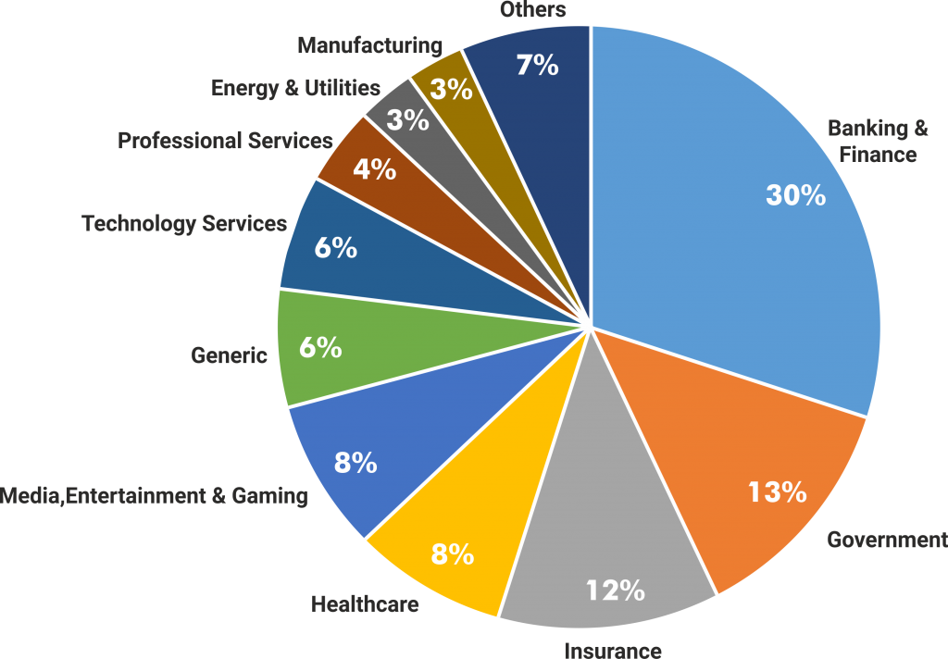

Fig. 1 Sectors Using Blockchain [2]

# related work

In the quest for innovation and efficiency, modern projects frequently rely on existing solutions as fundamental building blocks for development. This approach not only recognizes the expertise and advancements of those who came before us but also nurtures a collaborative ecosystem where ideas can evolve and confront new challenges. In our project, we wholeheartedly embrace this ethos, conscientiously integrating elements from existing solutions to enrich our endeavor. These existing solutions serve as guiding lights, offering insights and frameworks that shape the direction of our project.[4]

1. **ICT-Based Solutions for Farmers:** Several studies have explored the development of ICT solutions to provide farmers with valuable information and updates related to agricultural techniques, products, weather forecasts, and news. These solutions typically offer interfaces that allow farmers to interact via text or speech input, facilitating access to relevant information.
2. **Mobile Applications for Agricultural Updates:**

Researchers have proposed mobile applications designed to cater to the needs of farmers by providing instant updates on agricultural matters. While these applications offer valuable services, some limitations, such as language barriers (e.g., availability only in English), hinder their effectiveness in reaching a wider audience of farmers.[3]

1. **Blockchain in Agriculture Supply Chain Management:**

The incorporation of blockchain technology into agriculture has shown promise, particularly in improving the efficiency of supply chain management. By leveraging blockchain, the need for extensive data verification is reduced, leading to enhanced accuracy and reliability in supply chain operations. However, it's noted that current implementations primarily benefit producers by ensuring data accuracy for the supply chain.

1. **Decentralized Agricultural Tracing Systems:**

Researchers have explored the use of blockchain technology to develop decentralized agricultural tracingsystems. These systems aim to collectively maintain and provide trust and reliability in supply chain management by safeguarding immutable data related to production and supply. While beneficial for producers in terms of data integrity, the broader implications and adoption challenges of such systems remain subjects for further exploration.[5]

Overall, the analysis underscores the ongoing efforts to leverage technology, including ICT and blockchain, to address various challenges faced by farmers and enhance the efficiency and reliability of agricultural processes, particularly in supply chain management and information dissemination.

# Proposed Methods and its Architecture

# C:\Users\Dattasai vadla\AppData\Local\Packages\5319275A.WhatsAppDesktop_cv1g1gvanyjgm\TempState\30EF30B64204A3088A26BC2E6ECF7602\WhatsApp Image 2024-02-18 at 01.18.54_2ef57fcb.jpg

Fig. Use Case Diagram

## **Sellers**

To start their journey, sellers must first register by providing a valid email address and mobile number for communication purposes. After registration, it's the admin's responsibility to activate these seller accounts. Once activated, sellers gain access to the system and can log in. They are then empowered to add new items, update existing listings, and adjust item prices. This autonomy allows them to expand their market reach and diminishes the reliance on intermediaries during the selling process.

1. ***Buyers***

Buyers follow a similar registration process, providing valid email and mobile information for future communication. Admin approval is required for these buyer accounts to become active, granting users access to the system. Buyers can then browse and purchase products that meet their needs. They have the freedom to add products to their shopping cart and remove items as necessary. Once they've finalized their selections and verified their cart, users can proceed to the checkout process.

1. ***Admin***

Administrators access the system using their own credentials. Their role involves activating both seller and buyer accounts, ensuring that only activated users can log in. Additionally, the admin user has oversight over all transactions conducted by buyer users. The admin interface provides visibility into all blockchain transactions, displaying details of previous blocks and hash values for comprehensive monitoring.

SCHEMATIC FLOW DIAGRAM OF PROPOSED WORK

The schematic flow diagram illustrates the functionalities of the proposed portal. Users first register and log in as either a buyer or a seller. Depending on their role, the portal displays the respective home page. Buyers can browse, search, view, add items to their cart, and proceed to purchase. Sellers, on the other hand, can manage item quantities by adding, deleting, or updating listings, facilitating sales. Transactions are recorded on the blockchain when an item is purchased or sold. Upon completion of activities, users can log off through the interface to end their session.

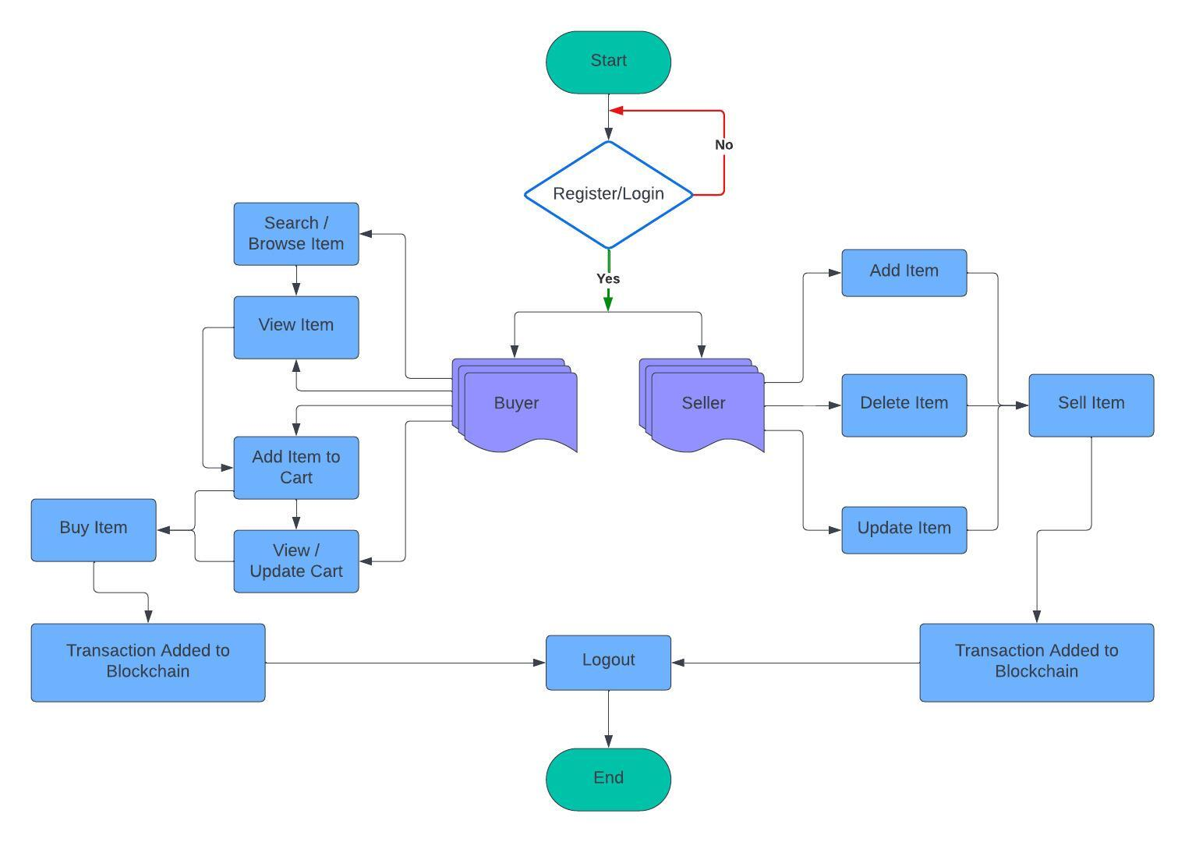

Fig. Schematic Flow Diagram

IV.CONCLUSION

Blockchain technology holds immense potential to revolutionize the agricultural sector by securely maintaining farmers' data and ensuring the integrity of transactions and crop sale prices. In this project, a blockchain-based portal addresses the critical issue of demand and fair pricing for crops, thereby enhancing crop security for farmers. Through the portal, farmers can register and sell their crops, with each transaction recorded immutably on the blockchain. This transaction captures crucial details such as crop specifications, committed purchase price, and quantity purchased.

The immutable nature of blockchain technology guarantees that farmers receive a fair and legitimate price for their crops, while also reducing the operational costs associated with traditional selling and buying methods. By leveraging blockchain, this project not only empowers farmers with greater control over their agricultural transactions but also fosters transparency and efficiency throughout the agricultural supply chain. Moreover, the implementation of blockchain technology in agriculture has the potential to streamline processes, mitigate risks associated with fraud and counterfeiting, and facilitate access to financial services for farmers in remote areas.

Furthermore, the transparency provided by blockchain can strengthen trust between stakeholders in the agricultural value chain, including farmers, buyers, distributors, and consumers. This increased trust can lead to more sustainable and ethical practices, as well as greater accountability throughout the industry. Overall, the integration of blockchain technology in agriculture has the capacity to drive significant improvements in productivity, profitability, and sustainability, ultimately benefiting farmers and consumers alike.

##### References

[1] Hileman, Garrick, and Michel Rauchs. "2017 Global Blockchain Benchmarking Study." Available at SSRN 3040224 (2017).

[2] <https://www.esds.co.in/blog/blockchain-technology-a-silver-lining-to-bfsi-industry/>

[3] Yadav,Vinay Surendra, and A. R. Singh. “A Systematic Literature Review of Blockchain Technology in Agriculture.”

[4] Ghosh, Soumalya,A. B. Garg, Sayan Sarcar, PSV S. Sridhar, Ojasvi Maleyvar, and Raveesh Kapoor. "Krishi-Bharati: An Interface for Indian Farmers”. In Proceedings of the 2014 IEEE Students' Technology Symposium, pp. 259-263. IEEE, 2014.

[5] Zhu, Xingxiong, and Dong Wang. "Research on Blockchain Application for E-Commerce, Finance and Energy." In IOP Conference Series: Earth and Environmental Science, vol. 252, no. 4, p. 042126. IOP Publishing, 2019.

[6] https://www.researchgate.net/figure/Problems-faced-by-the-farmers-in-selling-their-produce\_fig2\_262525855